# CSS Guide – Shawn Rae

Overall Color scheme (Inspiration is Lavenders which can be seen attached in the photo below):

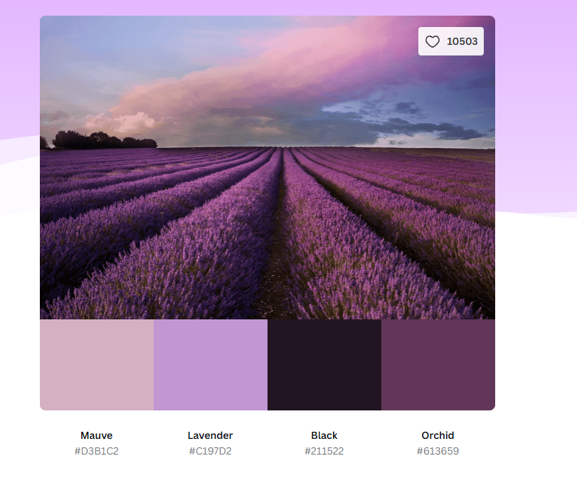

Background Color: rgb(193, 151, 210)

Main paragraph text color: Black

Headers: White

Navigation Bar:

* Set to the top of the screen
* Color: rgb(33, 21, 34)
* When Elements are hovered: rgb(211, 177, 194)

Hyper-links: White

* When Hovered: rgb(211, 177, 194)

Overall Format:

Navigation Bar will sit at the top with the options spanning across the top of the page with the title of the current page right below it.

Depending on the size of the screen, it will determine how big any fonts will be.

General styling (For Desktop Viewing)

Font – Serif Garamond

Font size:

* Header – 50 px
* Body text and link – 20 px

Padding – 15 px

Styling for Tablet viewing:

Font size:

* Header – 80 px
* Body text and links – 30 px

Styling for Phone viewing:

Font size:

* Header – 100 px
* Body text and links – 40 px

List of Features:

* Information about company (landing page)
* About me Page
* Services Offered (Consultation)
* Book a consultation
  + Redirects to login page
  + Drop box to choose whether person logging in is a customer or staff
* Customer login:
  + Booking status
  + Details
* Staff login:
  + Received request page
  + Details + action

Landing Page:

About Page:

Service Page:

Book a Consultation:

Login Page:

Images being used:

Lavender_Field.jpg – Photo of a Lavender field taken from pixabay <https://pixabay.com/photos/lavender-lavender-field-france-4777780/>